HELP GUIDE

Signing In and Out of OneUSG Connect

Employees can sign in and out of the OneUSG Connect system on the OneSource home page (https://onesource.uga.edu).
On the University System of Georgia (USG) page, after selecting UGA as your university, you will be presented with a Central Authentication Service (CAS) authorization screen to sign in to the OneUSG Connect system.
This Help Guide will show you how to sign in and out of the OneUSG Connect system.

Step | Action
To login to the OneUSG Connect system, go to the OneSource home page (https://onesource.uga.edu).

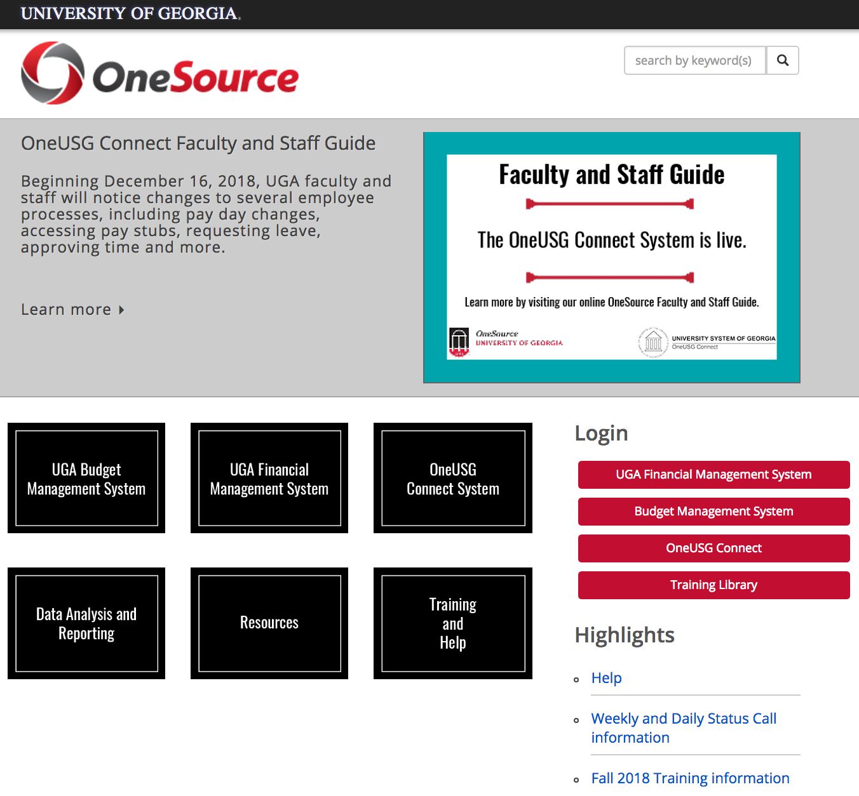

Click on OneUSG Connect under the Login menu.

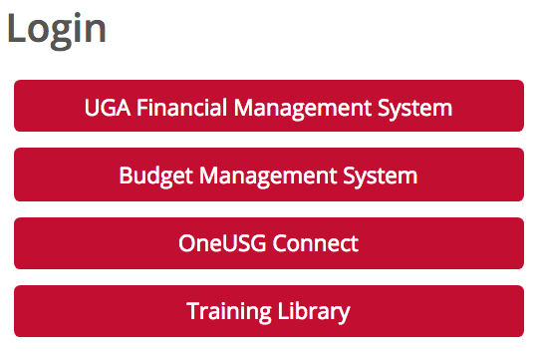
The USG Single Sign-on Authentication page will be displayed.

Note: The OneUSG Connect system is used by all University System of Georgia (USG) universities.

Click the University of Georgia icon.

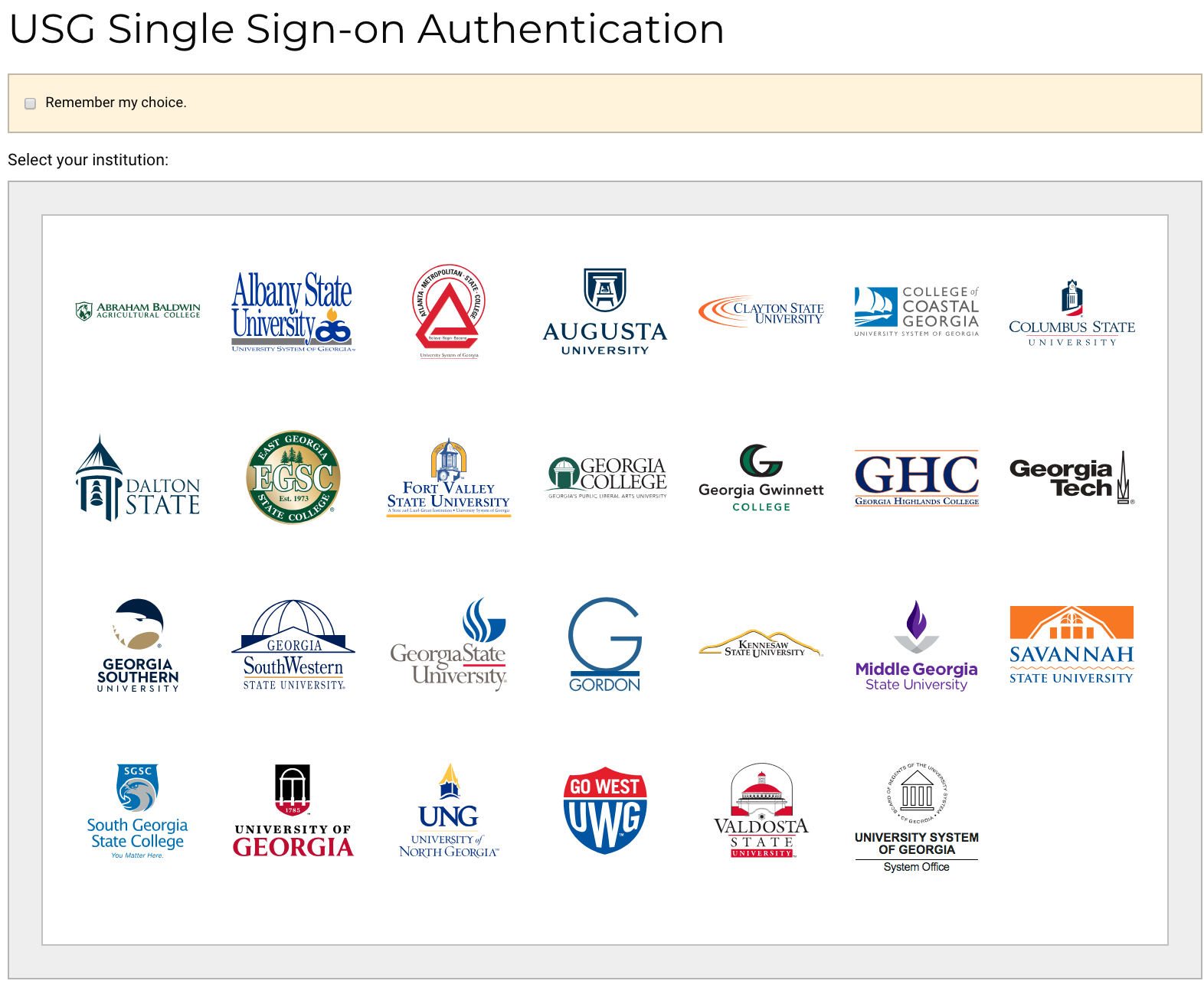
The University of Georgia Central Authentication Service page will be displayed.

Enter your Username and Password, and click the LOGIN button.

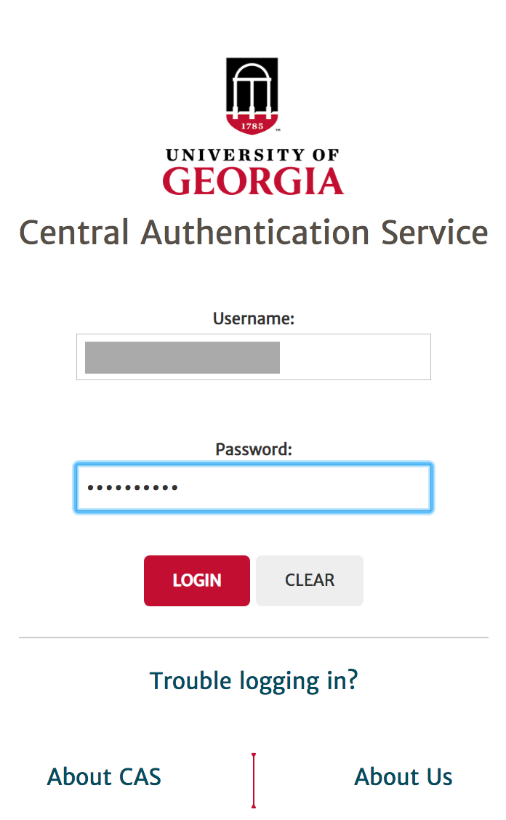

You will be prompted to authenticate your identity.

Select a method that you want to use among the Send Me a Push, Call Me, and Enter a Passcode options.

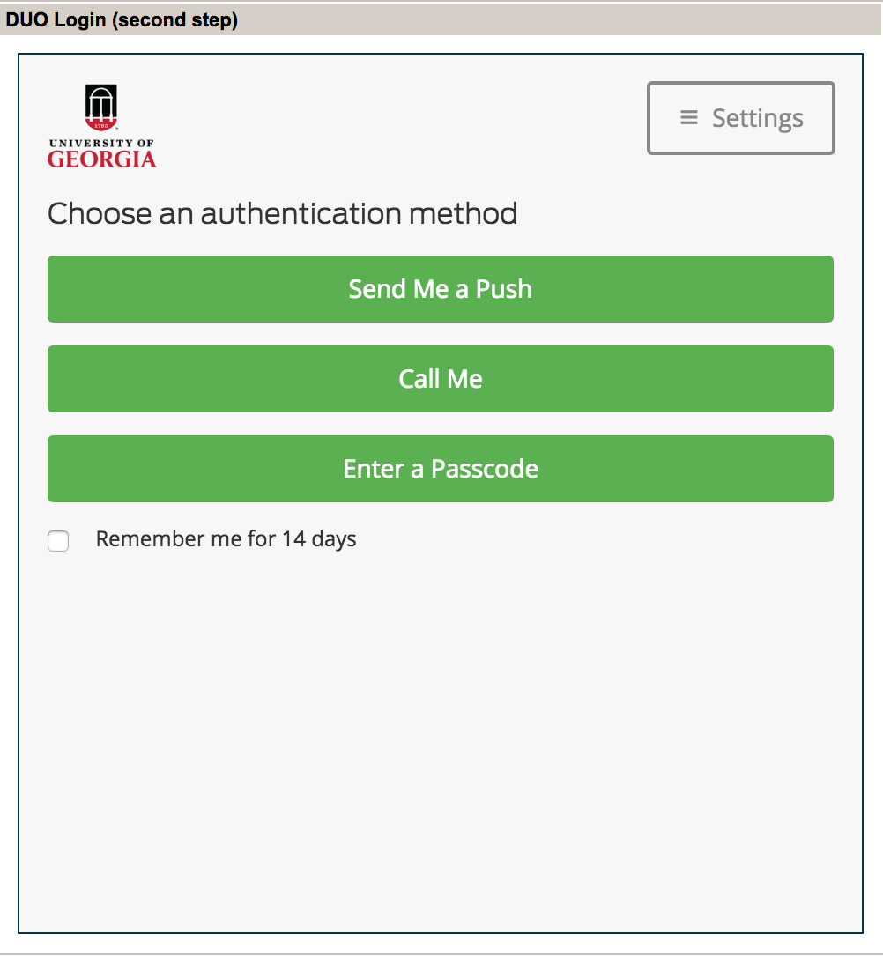

Note: To use ArchPass (UGA’s two-step login powered by Duo), you are required to enroll a device with the Duo application. You can enroll any smartphone, mobile phone, landline phone or tablet.

For more information, go to https://confluence.eits.uga.edu

The differences among the three methods (Call Me, Send Me a Push, and Enter a Passcode) are explained below.

If you select the Call Me option, you will receive an automated phone call from UGA. Once you receive the call and press 1, following the instructions, you will be prompted to proceed to the Employee Self Service page. This option can be beneficial for those who use landlines or non-smart cell phones.

6. | If you click the Send Me a Push option, you will receive the following message (University of Georgia Identity Provider) from UGA on your phone. Once you click the green Approve button, you will be prompted to proceed to the Employee Self Service page.  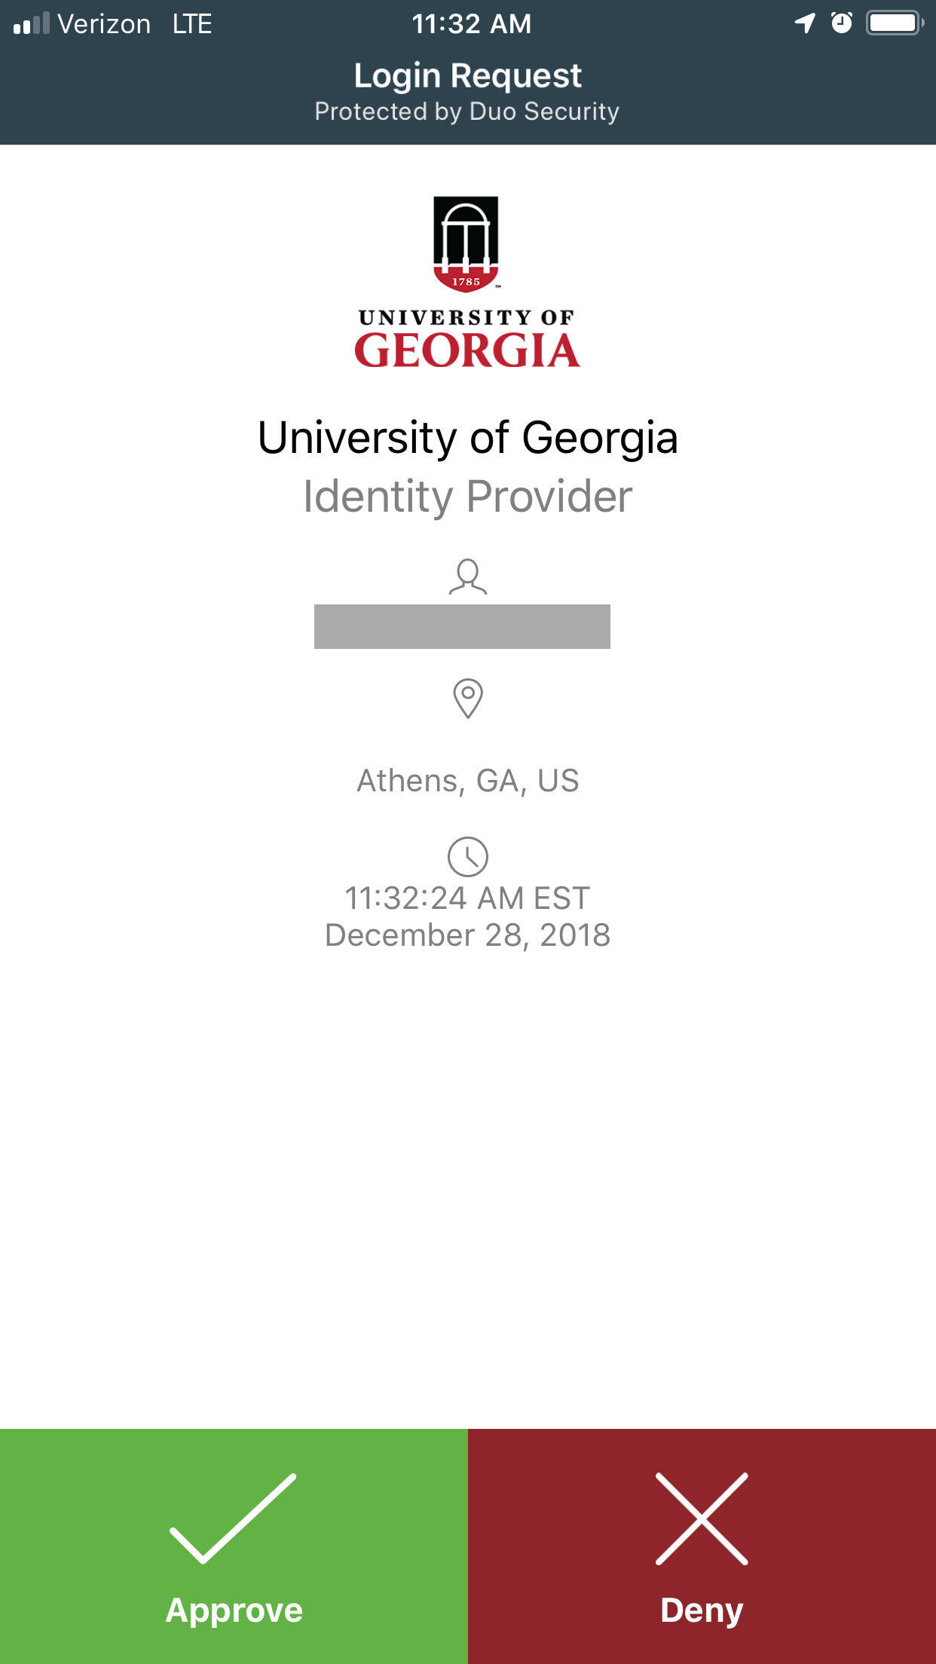  Click the Approve button.  If you select the Enter a Passcode option, the Duo Mobile application will open on your phone. You will see the following screens:  2. A 6-digit number will appear.  - Click the drop-down button.  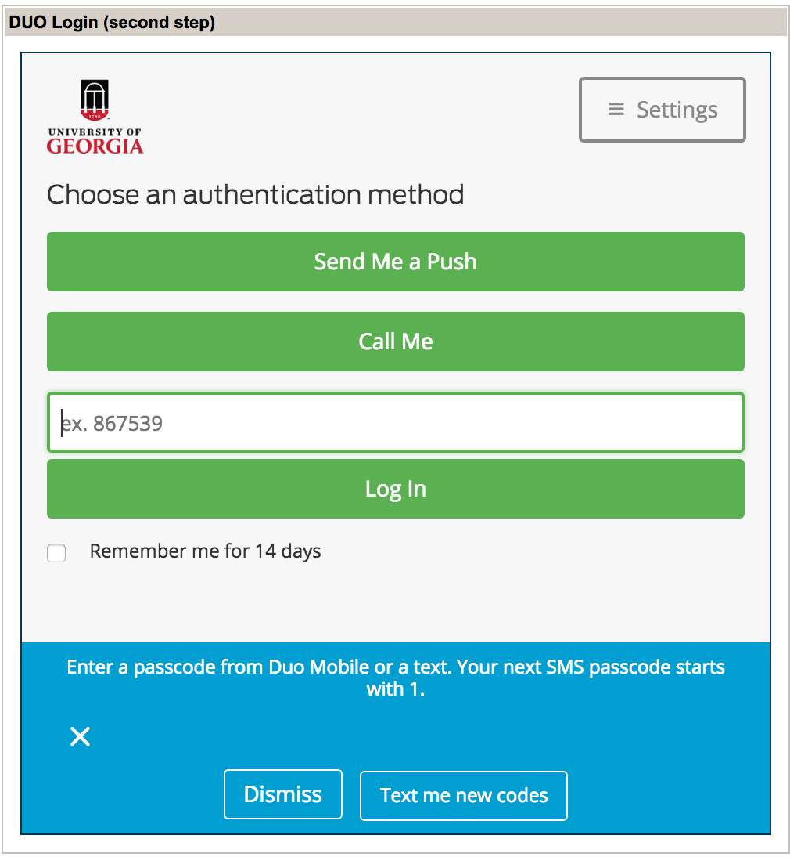  3. Enter the 6-digit number here.  4. Click the Log in button.
 | If you want to skip this step for the next 14 days, click the checkbox next to Remember me for 14 days.
The Employee Self Service page will be displayed.

